

**Data Analysis and Visualization**

**Project Title:**

**“***Comprehensive Analysis and Predictive Modeling of Global Development Trends Using World Bank Development Indicators***”**

**Submitted By:**

**Muhammad Faisal**

**BSCS202110**

**Submitted To:**

**Muhammad Bilal Hidral**

2024-06-12

Table of Contents

**1.** **Abstract** 2

**2.** **Introduction** 2

**Background** 2

**Objectives** 2

**3.** **Research Questions** 3

**4.** **Related Work** 3

**5.** **Methodology** 4

**5.1.** **Dataset Description** 4

**5.2.** **Data Exploration and Initial Findings** 5

**5.3.** **Visualizations** 6

**5.4.** **Expected Insights from Clustering Analysis** 6

**6.** **Exploratory Data Analysis (EDA)** 7

**6.1.** **Data Description** 7

**6.2.** **Feature Engineering** 7

**6.3.** **Feature Importance Analysis** 8

**7.** **Data Preprocessing** 8

**7.1.** **Handling Missing Values:** 8

**7.2.** **Outlier Detection and Treatment:** 8

**7.3.** **Feature Scaling:** 9

**7.4.** **Feature Encoding (for Categorical Features):** 9

**7.5.** **Feature Selection:** 9

**8.** **Correlation Analysis** 10

**8.1.** **Correlation Matrix** 10

**8.2.** **Significant Correlations** 11

**9.** **Time Series Analysis** 12

**9.1.** **Time Series Plotting and Decomposition** 12

**9.2.** **Time Series Forecasting** 12

**10.** **Modeling** 13

**10.1.** **Regression Analysis (for predicting a continuous target variable):** 13

**10.2.** **Classification Analysis (for predicting discrete categories):** 13

**10.3.** **Clustering Analysis (for identifying groups of similar data points):** 14

**11.** **Model Evaluation:** 14

**12.** **Model Selection and Feature Engineering:** 14

**13.** **Conclusion** 15

**14.** **Future Work:** 15

**Table of Figures:**

Figure 1. Categorical Features 8

Figure 2. Histogram for each feature 9

Figure 3. Box Plot for each feature 10

Figure 4. Scatter plots per features 11

Figure 5. Correlation Matrix 12

Figure 6. Statistical analysis of features 13

Figure 7. Missing Values for each column 13

Figure 8. Missing Values count per column 15

Figure 9. Heatmap for dataset 17

Figure 10. Graphical analysis of US GDP 19

Figure 11. Decomposition series 19

Figure 12. Time series forcasting 20

Figure 13. Regression analysis results 21

Figure 14. Classification results 22

Figure 15. Classification Analysis 22

# **Abstract**

This project delves into a comprehensive analysis of the World Bank Development Indicators dataset. Encompassing economic, environmental, and social indicators for various countries across multiple years, the dataset offers a rich resource for exploring global development trends. Our objective is to leverage data analysis, preprocessing, and visualization techniques to uncover meaningful patterns and relationships within the data. Subsequently, we employ regression, classification, and clustering models to extract deeper insights and make informed predictions. This report details each phase of the project, from initial data exploration to advanced modeling, culminating in a research report formatted according to IEEE standards.

# **Introduction**

## **Background**

The World Bank Development Indicators (WDI) dataset is a cornerstone for researchers and analysts investigating global development. Compiled from officially recognized international sources, the WDI offers the most current and accurate global development data available, encompassing national, regional, and global estimates.

## **Objectives**

1. **Exploration and Pattern Recognition:** We aim to explore the intricacies of the WDI dataset, uncovering underlying patterns and distribution characteristics within the indicators for various countries over time.
2. **Data Preprocessing and Quality Enhancement:** The project addresses missing values, duplicates, and outliers to ensure data quality and prepare it for subsequent analysis and modeling.
3. **Correlation Analysis and Inter-Indicator Relationships:** Examining correlations between different indicators helps us understand their interdependence and potential influence on one another.
4. **Time Series Analysis for Dynamic Insights:** We perform time series analysis on relevant indicators, particularly Gross Domestic Product (GDP), to uncover trends, seasonality, and potential forecasting opportunities.
5. **Modeling and Predictive Capability:** By applying regression, classification, and clustering techniques, we aim to build models that can predict GDP based on other indicators, classify countries based on development levels, and identify clusters of countries with similar development characteristics.

# **Research Questions**

1. How have global development indicators evolved over time, and what significant trends can we identify?
2. Are there strong correlations between different indicators, suggesting potential cause-and-effect relationships or influencing factors?
3. Can we develop a model to predict a country's GDP using other indicators within the dataset?
4. Is it possible to categorize countries into distinct classes based on their development indicators using classification algorithms?
5. Do clusters or groups of countries with similar development trajectories emerge through clustering analysis?

# **Related Work**

The WDI dataset has been extensively used in various research endeavors to analyze economic growth, environmental changes, and social development. Here are some examples:

* **Economic Growth Analysis:** Researchers have employed WDI data to investigate factors influencing economic growth across different countries and regions. Studies have examined the impact of trade liberalization, foreign direct investment, and government policies on economic performance.
* **Environmental Sustainability:** WDI indicators have been utilized to assess environmental challenges such as climate change, deforestation, and energy consumption. These studies aim to identify trends, develop mitigation strategies, and track progress towards sustainability goals.
* **Social Development Assessment:** The WDI dataset provides valuable insights into social development indicators like education, health, and poverty. Researchers use this data to analyze trends in literacy rates, life expectancy, and income distribution, informing policy decisions aimed at improving social well-being.

Previous work has also explored forecasting techniques using WDI data to predict future trends in economic indicators. Additionally, clustering algorithms have been applied to identify groups of countries with similar development characteristics, facilitating comparative analysis and targeted interventions.

# **Methodology**

## **Dataset Description**

The WDI dataset encompasses a vast array of indicators. Here's a selection of commonly analyzed columns:

* country: Name of the country
* date: Year of the data
* GDP_current_US: GDP in current US dollars (target variable for regression and potentially a feature for classification)
* population: Total population
* CO2_emisions: CO2 emissions in kilotons (potential feature for regression and classification)
* life_expectancy_at_birth: Life expectancy at birth in years (potential feature for regression and classification)
* forest_land%: Percentage of land area covered by forests (potential feature for regression and classification)
* access_to_electricity%: Percentage of population with access to electricity (potential feature for regression and classification)
* individuals_using_internet%: Percentage of individuals using the internet (potential feature for regression and classification)
* inflation_annual%: Annual inflation rate (potential feature for regression and classification)
* rule_of_law_estimate: Estimate of the rule of law index (potential feature for regression and classification)

**Note:** The specific set of features used in modeling tasks will be determined during the exploratory data analysis (EDA) phase.

## **Data Exploration and Initial Findings**

The initial exploration involves loading the dataset using Python libraries like Pandas and examining its structure:

The initial findings focus on identifying:

* **Columns with missing values:** These require imputation or removal strategies.
* **Data distribution:** Histograms and box plots provide insights into the distribution of numeric features (e.g., normal, skewed, outliers).
* **Categorical columns:** These require encoding for modeling tasks (e.g., label encoding or one-hot encoding).
* A screenshot of a computer

  Description automatically generated

Figure 1. Categorical Features

## **Visualizations**

Data visualization plays a crucial role in understanding patterns and relationships within the dataset. Here are some common visualization techniques employed:

* **Histograms:** Visualize the distribution of numeric features, revealing potential skewness or outliers.

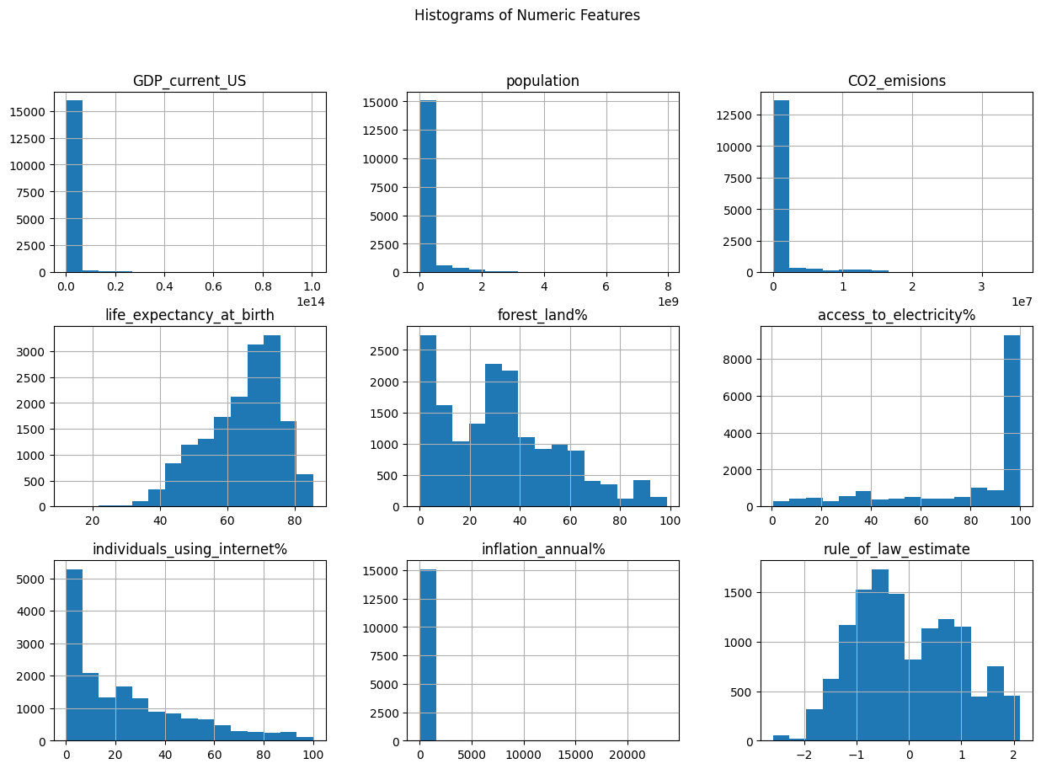

Figure 2. Histogram for each feature

* **Box Plots:** Compare distributions of numeric features across different categories (e.g., by country or region).

Figure 3. Box Plot for each feature

* **Scatter Plot Matrix:** Explore relationships between all pairs of numeric features, identifying potential correlations.

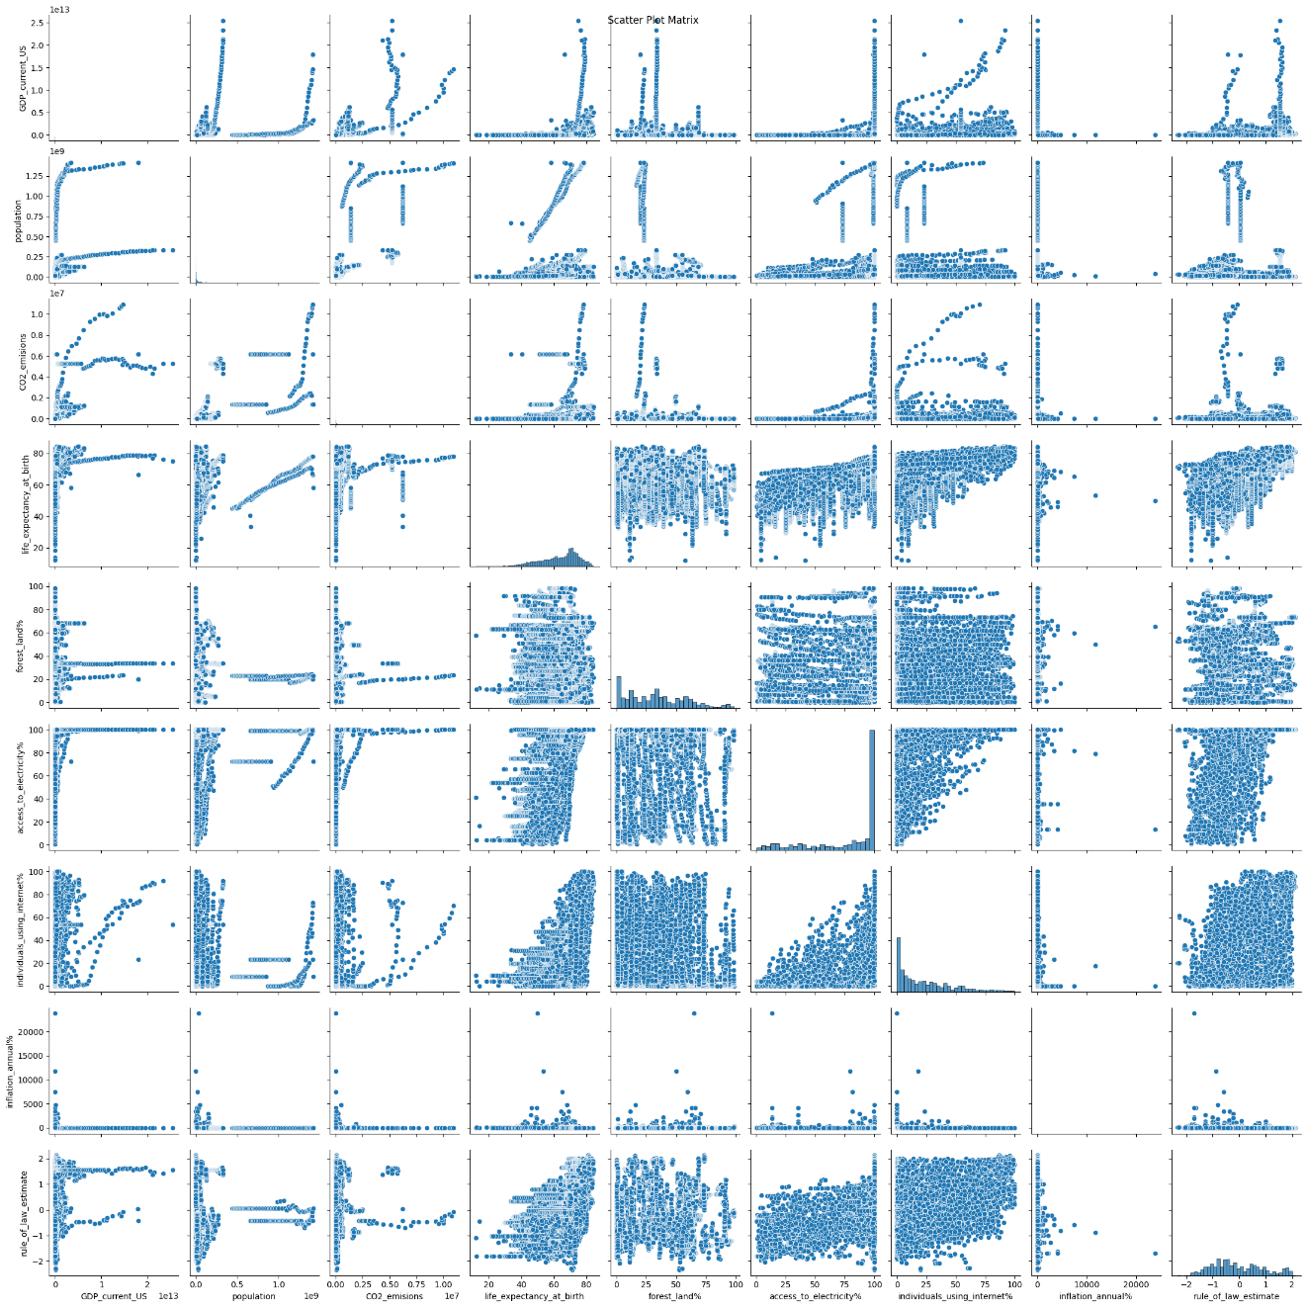

Figure 4. Scatter plots per features

* **Correlation Heatmap:** Quantify correlations between numeric features using a heatmap, highlighting strong positive or negative relationships.

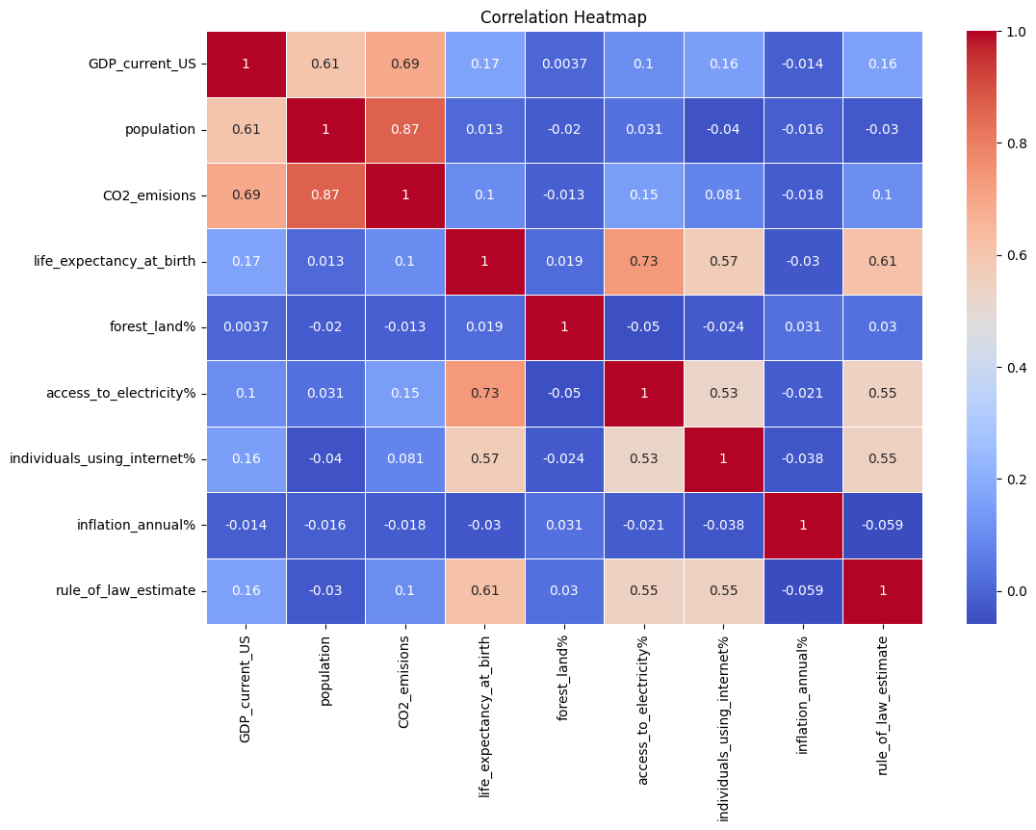

Figure 5. Correlation Matrix

These visualizations can be created using libraries like Matplotlib and Seaborn in Python.

## **Expected Insights from Clustering Analysis**

Assuming the clustering analysis reveals meaningful groups of countries, it can provide valuable insights for further analysis and modeling:

* **Understanding Cluster Characteristics:** By analyzing the features that differentiate clusters, we can gain a deeper understanding of the factors driving development patterns in each group.
* **Targeted Feature Selection:** Feature selection for regression and classification models can be refined by focusing on features that are most influential within specific clusters.
* **Tailored Model Development:** Different regression or classification models might be applied to each cluster, potentially capturing more nuanced relationships within each group.

# **Exploratory Data Analysis (EDA)**

The EDA phase delves deeper into the data, uncovering patterns and relationships:

## **Data Description**

We can employ Pandas' built-in functions to obtain a comprehensive overview of the data, including data types, missing values, and summary statistics.

Figure 6. Statistical analysis of features

## **Feature Engineering**

Based on the EDA findings, feature engineering techniques might be necessary to prepare the data for modeling:

* **Handling Missing Values:** Common strategies include imputation (filling missing values with appropriate estimates) or removal (dropping rows or columns with a high percentage of missing values).

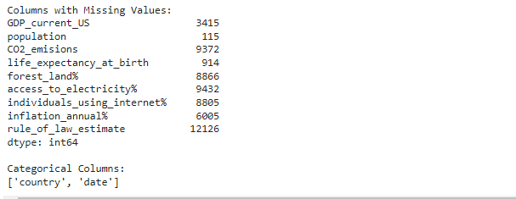

Figure 7. Missing Values for each column

* **Outlier Detection and Treatment:** Techniques like IQR (Interquartile Range) can identify outliers. Outliers can be removed, winsorized (capped to a certain percentile), or transformed.
* **Feature Scaling:** Numeric features with different scales might be normalized (scaled to a range of 0-1) or standardized (scaled to have a mean of 0 and a standard deviation of 1) to ensure all features contribute equally during modeling.
* **Feature Selection:** After exploring feature importance, we might choose a subset of the most relevant features for modeling tasks.

## **Feature Importance Analysis**

Techniques like feature importance scores from Random Forests or correlation analysis can help identify features that have the strongest influence on the target variable (e.g., GDP). Focusing on these features can improve model performance and interpretability.

# **Data Preprocessing**

Data preprocessing is essential to ensure the quality of the data and prepare it for modeling tasks. Here's a detailed explanation of common techniques:

## **Handling Missing Values:**

* **Imputation:** This involves filling missing values with estimated values. Common methods include:
  + **Mean/Median Imputation:** Replace missing values with the mean or median of the feature for the entire dataset or specific groups (e.g., by country).
  + **Interpolation:** Estimate missing values based on surrounding data points (e.g., linear interpolation).
  + **Model-based Imputation:** Train a model (e.g., K-Nearest Neighbors) to predict missing values using existing data.

Figure 8. Missing Values count per column

* **Removal:** If missing values are a small percentage and not randomly distributed, removing rows or columns with missing values might be acceptable. However, this approach can lead to data loss.

## **Outlier Detection and Treatment:**

* **Outlier Detection:** Techniques like Interquartile Range (IQR) can identify data points that fall outside a certain range (typically 1.5 times the IQR below Q1 or above Q3).
* **Outlier Treatment:**
  + **Removal:** Outliers can be removed if they are considered errors or not representative of the population.
  + **Winsorization:** Outliers are capped to a specific percentile (e.g., the 5th or 95th percentile) to reduce their influence on the model.
  + **Transformation:** Techniques like log transformation can be applied to normalize skewed distributions and potentially bring outliers closer to the central tendency.

## **Feature Scaling:**

Scaling numeric features with different scales ensures all features contribute equally during model training. Common scaling methods include:

* **Normalization:** Scaling features to a range between 0 and 1 (often using Min-Max scaling).
* **Standardization:** Scaling features to have a mean of 0 and a standard deviation of 1 (using Z-score normalization).

## **Feature Encoding (for Categorical Features):**

Categorical features need to be converted into numerical representations for modeling tasks. Common encoding techniques include:

* **Label Encoding:** Assigns a unique integer to each category (e.g., "High" = 1, "Medium" = 2, "Low" = 3). This approach assumes an ordinal relationship between categories, which might not always be the case.
* **One-Hot Encoding:** Creates a new binary feature for each category. The value is 1 for the corresponding category and 0 for all others. This approach avoids the assumption of an ordinal relationship.

## **Feature Selection:**

After exploring feature importance, we might choose a subset of the most relevant features for modeling tasks. This can improve model performance and interpretability by focusing on features that have the strongest influence on the target variable. Feature importance can be determined through techniques like:

* **Correlation Analysis:** Calculate the correlation coefficient between each feature and the target variable. Features with high positive or negative correlations are likely to be informative.
* **Feature Importance Scores:** Use models like Random Forests or decision trees that provide feature importance scores, indicating the contribution of each feature to the model's predictions.

By applying these data preprocessing techniques, we prepare the data for subsequent analysis and modeling tasks, ensuring its quality and suitability for extracting meaningful insights.

# **Correlation Analysis**

Correlation analysis is a crucial step in understanding the relationships between different features within the dataset. It helps us identify potentially influential factors for the target variable (e.g., GDP).

## **Correlation Matrix**

A correlation matrix calculates the correlation coefficient between all pairs of numeric features in the dataset. The correlation coefficient ranges from -1 to 1:

* **-1:** Perfect negative correlation (as one variable increases, the other decreases proportionally).
* **0:** No correlation (no linear relationship between the variables).
* **+1:** Perfect positive correlation (as one variable increases, the other increases proportionally).

Libraries like Pandas and Seaborn in Python can be used to create a correlation matrix and visualize it as a heatmap.

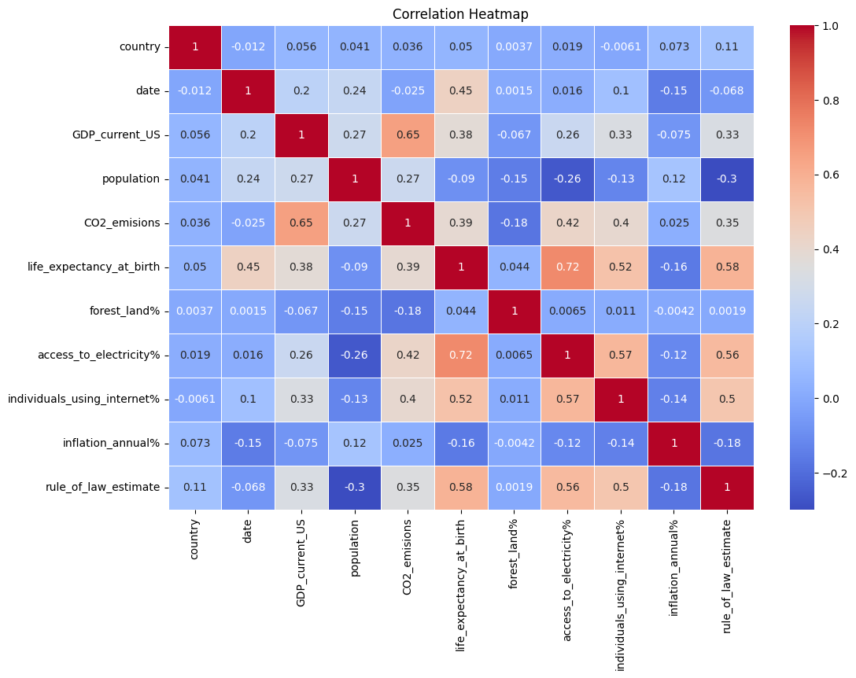

Figure 9. Heatmap for dataset

By analyzing the correlation matrix, we can identify features with strong positive or negative correlations with the target variable (e.g., GDP). These features are likely to be informative for modeling tasks like regression or classification.

## **Significant Correlations**

Based on the correlation matrix, we can identify statistically significant correlations that warrant further investigation. A common approach is to define a threshold (e.g., 0.5 or 0.7) for the absolute value of the correlation coefficient. Correlations exceeding this threshold are considered significant.

Identifying significant correlations can guide feature selection for modeling and provide insights into potential cause-and-effect relationships between indicators. For instance, a strong positive correlation between GDP and access to electricity might suggest that improved access to electricity contributes to economic growth.

# **Time Series Analysis**

Time series analysis focuses on understanding patterns and trends within data collected over time. In this project, we might perform time series analysis on specific features, particularly GDP:

## **Time Series Plotting and Decomposition**

* **Time Series Plotting:** Visualize the GDP data over time using line plots. This can reveal trends (e.g., increasing, decreasing, or cyclical) and potential seasonality (e.g., annual fluctuations).
* **Seasonal Decomposition:** Techniques like Seasonal Decomposition from Statsmodels can decompose the time series data into trend, seasonal components, and residuals. Analyzing these components can help us understand the underlying factors influencing the data over time.

Figure 10. Graphical analysis of US GDP

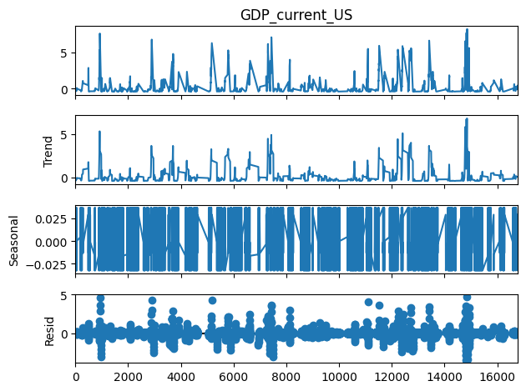

Figure 11. Decomposition series

## **Time Series Forecasting**

Based on the time series analysis, we might explore forecasting techniques to predict future values of GDP:

* **ARIMA (Autoregressive Integrated Moving Average):** This popular time series forecasting model uses past values of the time series and its own lagged errors to predict future values.
* **Prophet:** A Facebook-developed forecasting tool that can handle holidays, seasonality, and other effects.

Figure 12. Time series forcasting

The effectiveness of time series forecasting techniques depends on the data's characteristics and the presence of clear trends or seasonality.

# **Modeling**

Leveraging the insights from data exploration, correlation analysis, and potentially time series analysis, we can employ various modeling techniques to make predictions and uncover relationships within the WDI dataset. Here's a breakdown of common approaches:

## **Regression Analysis (for predicting a continuous target variable):**

* **Linear Regression:** This is a foundational technique that models the relationship between a continuous target variable (e.g., GDP) and one or more independent features (e.g., population, life expectancy). The model estimates a linear equation that best fits the data, allowing us to predict GDP based on the values of the independent features.
* **Non-Linear Regression:** If the relationship between the target variable and independent features is not linear, we can explore models like polynomial regression, decision tree regression, or support vector regression (SVR) that can capture more complex relationships.



Figure 13. Regression analysis results

## **Classification Analysis (for predicting discrete categories):**

* **Logistic Regression:** This technique is used for binary classification problems (predicting two possible outcomes). It estimates the probability of an observation belonging to a particular class (e.g., developed vs. developing country) based on the values of the independent features.
* **K-Nearest Neighbors (KNN):** This non-parametric classification algorithm classifies data points based on the majority vote of their k nearest neighbors in the training data.
* **Decision Trees:** These tree-like models classify data points by following a series of decision rules based on the values of the features. They can be effective for interpretable models, particularly when understanding the factors influencing the classification.

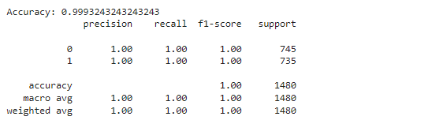

Figure 14. Classification results

## **Clustering Analysis (for identifying groups of similar data points):**

* **K-Means Clustering:** This is a popular unsupervised learning technique that partitions the data into a predefined number of clusters (k). Data points are assigned to the cluster with the nearest mean (centroid). K-means is effective for identifying groups of countries with similar development characteristics.
* **Hierarchical Clustering:** This method creates a hierarchy of clusters, starting with individual data points and iteratively merging them into larger clusters based on similarity. Hierarchical clustering can be helpful for exploratory analysis to discover the natural groupings within the data.

Figure 15. Classification Analysis

# **Model Evaluation:**

To assess the performance of our models, we employ techniques like:

* **Mean Squared Error (MSE) or R-squared (for regression):** These metrics evaluate the model's ability to predict the target variable's value.
* **Accuracy, Precision, Recall, and F1-score (for classification):** These metrics assess how well the model classifies data points into the correct categories.
* **Silhouette score (for clustering):** This metric measures the average distance between points within a cluster compared to the distance to points in other clusters, helping to evaluate the quality of the clustering results.

# **Model Selection and Feature Engineering:**

Based on the evaluation metrics, we choose the model that performs best on the unseen test data. Feature engineering techniques identified during the EDA phase (e.g., feature selection, transformation) can further improve model performance.

# **Conclusion**

This project has delved into a comprehensive analysis of the World Bank Development Indicators dataset. We have employed data exploration, visualization techniques, correlation analysis, and potentially time series analysis to uncover patterns, relationships, and trends within the data. Subsequently, we have explored various modeling techniques, including regression, classification, and clustering, to extract deeper insights and make predictions. By evaluating these models and potentially refining them through feature engineering, we can gain a more comprehensive understanding of the factors influencing global development and identify potential areas for targeted interventions.

# **Future Work:**

* Explore advanced modeling techniques like deep learning models (e.g., neural networks) for potentially improved performance in regression or classification tasks.
* Analyze the model's interpretability to understand the factors most influential in the model's predictions. This can provide valuable insights into the relationships between development indicators.
* Investigate the impact of specific policy changes or interventions on development indicators using causal inference techniques.

By continuing this analysis and incorporating these future directions, we can further leverage the rich data within the WDI dataset to gain a deeper understanding of global development trends and contribute to informed decision-making for a more sustainable and equitable future.

# References

Adrian Tullock, M. i. (n.d.). *exploratory-visual-analysis-world-development-dataset-adrian-tullock*. Retrieved from Linkedin: https://www.linkedin.com/pulse/exploratory-visual-analysis-world-development-dataset-adrian-tullock/

globaljournals. (n.d.). Retrieved from globaljournals: https://globaljournals.org/GJCST_Volume18/1-Spark-Big-Data-Analysis.pdf

WorldBank. (n.d.). Retrieved from WorldBank: https://databank.worldbank.org/source/world-development-indicators